**Complete Task Scenario:**

The supervisor, Mr. Smith creates a task and assigns it to Ali, the intern. Ali works on the task and after finishing it, marks it as completed, pressing the “Complete Task” command. Mr. Smith is immediately notified and after he sees the task and if he considers the task finished he marks it as checked. The intern can see the updated checked status. Otherwise Ali will continue to work on the task.

**Sequence Diagram:**

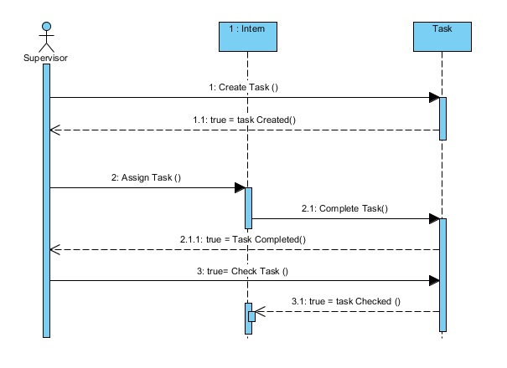

**State Diagram:**

